More Manipulating

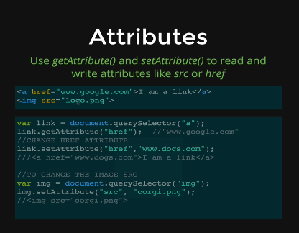

GetAttribute will retrieve the href

SetAttribute will reassign it